# Handout: Eduhouse Single Sign-On Configuration

Eduhouse Platform supports Signing-in with two different methods.

* Password based Sign-in
* Microsoft Single Sign-On

# Taking Single Sign-on To Use (Admin Consent)

It is possible to replace the password-based sign-in with the Single Sign-On (SSO). To take the SSO to use **you must setup so called Admin Consent to your Azure platform’s Active Directory**. This work should be done by your IT department.

We have created a short video tutorial (<https://www.youtube.com/watch?v=wnt8Ri7EylE>) what takes you through the steps. Single Sign-on is usually opened for the whole organization, but it can also be configured to work for limited user groups or individual users in your Active Directory from the Azure Marketplace Eduhouse App.

Eduhouse receives the following information. We do not have any further access to your Active Directory and the only time we can access the information is when the user logs-in to the service.

* Name
* Email
* UPN
* Company Name
* Department
* ObjectId
* EmployeeID

# User Registration Through SSO

Easiest way to use SSO is not only to log-in with it, but also allow user registration through SSO. To do this **Eduhouse has to configure our platform for you**. This can be done directly with our sales or later by contacting our Customer Support team.

The configuration is done with your domain-name(s). Have a list of the domain-names at hand you want to allow the registration from.

Not for IT: We don’t use the domain of an email field for the matching but the UPN, as it is the recommended practice.

Example:

*@foo.com*

*@bar.com*

It is also possible to do more complicated rules based to the *Company Name* or *Department* fields. For this setup it is usually best to have a short meeting with IT representative present.

# FAQ

*Does Eduhouse support only SSO through Azure? Are other methods of SSO supported?*

Currently no. This is an often-requested feature and will be addressed in the near future.

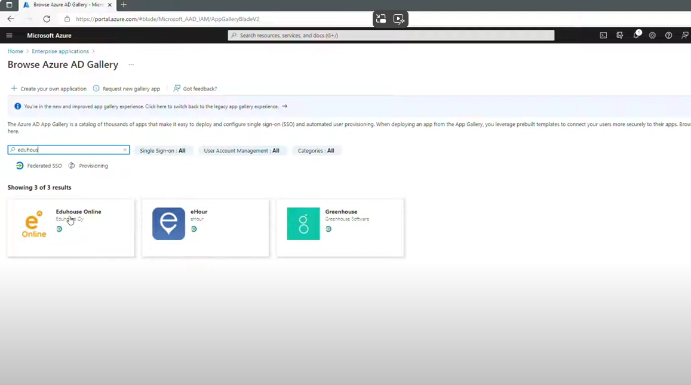

[Eduhouse Admin Consent ENG](https://www.youtube.com/watch?v=wnt8Ri7EylE)